Task#1
using System;

namespace Salary1
{
class Program
{
static void Main(string[] args)
{
int Bs, grade;
string name;
double totalsalary;
Console.WriteLine("What's your name");
name=Console.ReadLine();
Console.WriteLine("what,s your basic salary");
Bs = Convert.ToInt32(Console.ReadLine());
Console.WriteLine("What's your grade");

grade = Convert.ToInt32(Console.ReadLine());
switch(grade )
{
case 17:
totalsalary = Bs + (0.05 * Bs) + (0.025 * Bs) +( 0.01 * Bs)- (0.075 * Bs);
Console.WriteLine("MR.{0} YOUR TOTAL SALARY IS {1}",name,totalsalary);
break;
case 18:
totalsalary = Bs * (0.055 * Bs) + (0.03 * Bs) * (0.015 * Bs) - (0.075 * Bs);
Console.WriteLine("\t\t Mr.{0} your total saiary is {1} ", totalsalary);
break;
case 19:
totalsalary = Bs * (0.06 * Bs) + (0.033 * Bs) * (0.015 * Bs) - (0.075 * Bs);
Console.WriteLine(" Mr.{0} your total salary is {1}",name,totalsalary);
break;
}
}
}
}
Output:

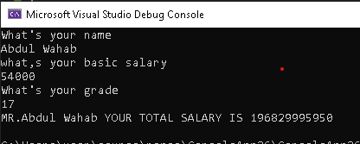
Task 5
using System;

namespace ConsoleApp27
{
class Program
{
static void Main(string[] args)
{
for (int i=1;i<= 3;i++)
{
Console.WriteLine("Chapter{0}",i);
for(int j=1;j<=5;j++)
{
Console.WriteLine("\t section {0}.{1}",i,j);
}
}
}
}
}
Output:
